IP Camera

Smartphone -ready colour night/day

network camera with pan, tilt and zoom
DYN-629
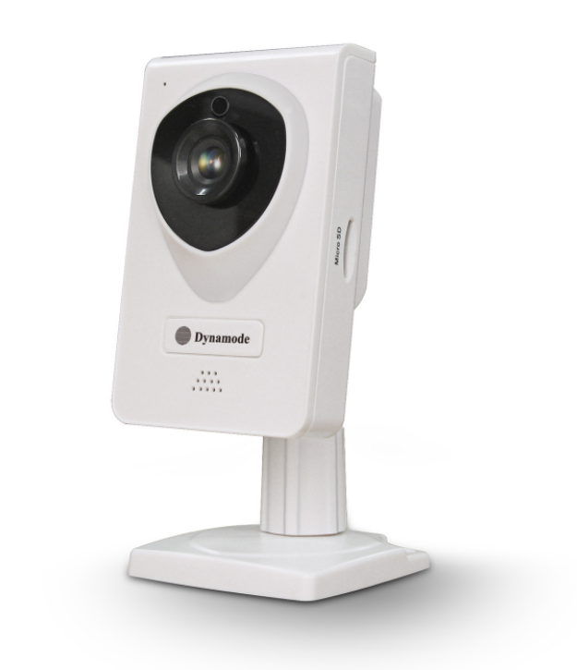

Specification
Product type：IP camera
Operation system：Embedded operating system
Web protocol：TCP/IP, UDP/IP, HTTP, SMTP, FTP, DHCP, DDNS, UPNP, NTP, RTSP, ONVIF
LAN port：10Base-T/100Base-TX
Wifi：802.11 b/g/n
Resolution：720P, 640*360, 320*180
Compression mode：H.264/M-JPEG
Max frame rate：30fps
Lens：f=3.6mm, F=2.0
Min. illumination：IR on, 0 Lux
Electronic shutter：1/50s(1/60s)-1/100,000 s
SNR：48db
Safety performance：Three levels of user rights
Install mode：Wall-mounted / ceiling-mounted
Other performance：PC software,support for Microsoft Windows 98/2000/XP/Vista/Windows 7/Mac OS,And the Internet Explorer6.1 and above version or browser compatibility, Firefox, etc., provide iSmartViewPro client software
Power supply：DC 5V
Sensor：CMOS Sensor
IP camera performance：Support video control, Two-way voice talkback, motion detection, external alarm(sends information to alarm the server by Email, FTP);Manufacturers provide free DDNS, and has been written into equipment; 10pcs IR LEDs, 8meters effectively; Platform level angle 350°, 120 °vertical angle; automatically control through the photoresistor;
Audio input：With microphone
Audio output：With loudspeaker
Alarm in：Not supported
Alarm out：Not supported
Power consumption：Power<4W
Body size：60*70*130mm
Product weight：0.14kg
Environment temperature：-10℃--50℃℃
Environment humidity：below 85% RH

